Important Computers through the decades
The world’s first programmable electronic computer – 1944 The British Colossus computer in Bletchley Park. But it remained top secret for many decades because it cracked secret codes.
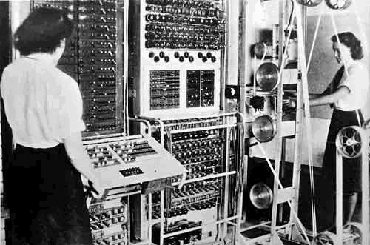
Search term: computer colossus

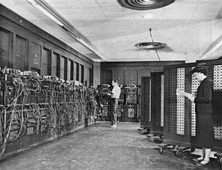
The first publicly known, general purpose computer appeared in 1945 and was called the ENIAC. It weighed 30 tons!
Search term: ENIAC computers

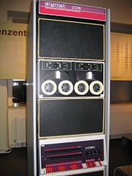
The cost of early computers was so high that only governments could afford them.
But in the 1970’s electronics became cheaper and the first practical business computers appeared.
A very successful business computer: The DEC PDP-11 with many new features. It was so successful that it sold from 1970 all the way through to 1990.
Search term: PDP11 computer

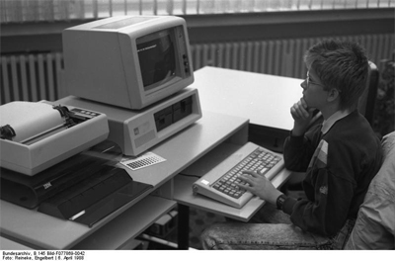
The 1980’s was the age of the first personal computer.
IBM launched the IBM Personal Computer in 1981.
For the first time, ordinary people could (just about) afford their own computer.
Search term: IBM Personal Computer

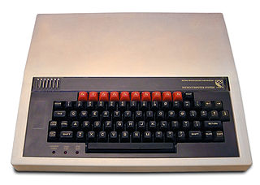
But for most people, computers were mysterious things that only scientists and engineers knew about.
To change all that, the BBC Micro was created in 1981 with the plan to let school children have a go with learning to program a computer for themselves.
This is when computer games really took off as thousands of young people invented new games to play.
Search term: BBC Micro
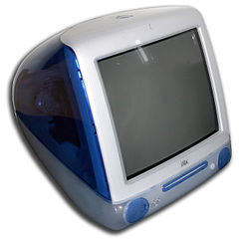
In the 1990’s computers started to have a bit more style and they continued to drop in price
This is the Apple iMac G3 which was an all-in-one computer.
CD-ROM drives appeared that allowed much larger programs and videos to be stored cheaply.
Search term: Apple iMac G3

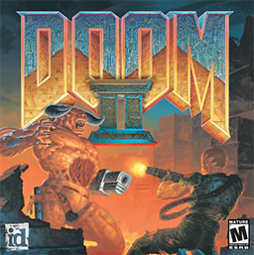

Computer Graphic cards also became much more powerful which allowed games to become ever faster and more exciting.
Search term: “awesome history of 3D graphics”

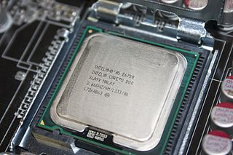

In the 2000’s, computers became faster and faster, with each new generation toppling the previous one.
But there came a point where computer chips ran so hot that it was not practical to make a single CPU go any faster. It would simply burn out like a light bulb.
The answer has been to include more than one ‘core’ inside the computer. One core can run one program at a time. The modern computer can have two, four or more ‘cores’. Each one is able to run its own software application.
Search term: Multi-core computers

Another interesting development is the sheer number of shapes and sizes that computer now come in.


