Worksheet 1b: Inputs, processes and outputs
Activity 1:
Identify the inputs, processes and outputs for the following real-world applications:
Passport Scanner (Details)  Input: Passport barcode is scanned  Process: Data from barcode is checked against national database  Output:  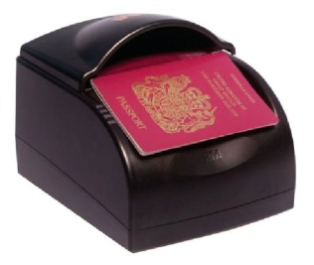 |  | Automatic Windscreen Wiper (Details)  Input:  Process:  Output: Wipers switch on
Fingerprint Clocking-in or Registration System (Details)  Input: Fingerprint on sensor  Process:  Output: |  | 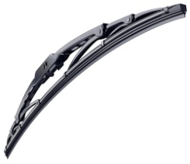  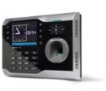  Automatic Smoke Detector (Details)  Input:  Process:  Output:  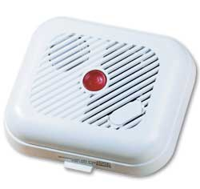

Activity 2:
- Identify all of the input devices at a supermarket self-checkout machine. What data is input for each device?
Input Device | What data is input?

- What information needs to be stored on the supermarket computer in order to make everything work correctly?

- Where might this data be stored?

- What type of storage device could the data be stored on and why?

- Identify the output devices at a supermarket and state what the output would be.
Output Device | What data is output?

