Python worksheet 1
 | Task | Completed
1 | Open Idle on your computer. Idle is the program that allows you to write your Python code.
Click the windows button. | Type Idle and open Idle (Python 3.6). | You will open the shell of the Idle program.

2 | The shell is used to type basic code. For instance, you can do some basic Maths calculations. Type the following calculations followed by the enter key. Write the answer next to each one.
- a) 3*3
- b) 48/3
- c) 270 + 426
- d) 155578 – 1234
- e) 8 ** 2
You will see that each calculation takes the same time to complete and that we use different mathematical operators for multiply and divide in Python than when we are doing Maths in our exercise books.
3 | When we write our code in Idle we don’t usually use the shell. Instead we use the editor. Open the editor on your computer.
Click File> New File | Your new window should look like this | Click File > Save As | Save in documents with a relevant folder and the filename ‘Hello world’

Python
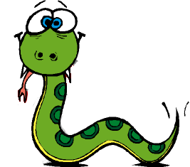
Python is its own language and it has its own syntax. This is the structure of statements and words in that are used in Python. A bit like English has its own structure of sentences and words and so do other languages such as Spanish or Urdu. There are other computer programming languages such as Java or C++.

Print statements
By using the print function, you can produce simple statements.

The print command here is colour coded. It is purple and that means it is part of the Python library. Python functions are case-sensitive which means they must always be in lower case (small letters). The statement you wish to ‘output’ must be inside opening and closing brackets and speech marks. If you have done this correctly, it will appear in green.
4 | Type the code shown above into your Idle editor and run the code.
Running your code
Click F5 on the top row of your keyboard | Click OK to save | Your code will output in the shell

Success – you have now created your first Python program.

 | Question | Mark
1 | What is the name of the program used to write Python code? | 1
…………………………………………………………………………………………………………….
2 | The following describes something important in programming:  “The structure of statements and words in a computer language”.  What does it describe? (Tick 1) | 1
- a) Loops
- b) syntax
- c) variables
- d) code
3 | Mathematical Operation Symbol  Addition +  Subtraction  Multiplication  Division  Fill in the missing symbols from the table above | 3
4 | What happens if you type in the 2 * 3 and then press enter? | 1
- a) It produces the value 6
- b) It produces a syntax error
- c) It produces the value 5
- d) Nothing
5 | Explain what has happened with 8**2 that was calculated earlier. Why has it produced this value? | 1
…………………………………………………………………………………………………………….
6 | What part of idle is used to do most of your coding? | 1
- a) The editor
- b) The shell
- c) The Python window
- d) The file

 | Question | Mark
7 | What part of idle is shown here?  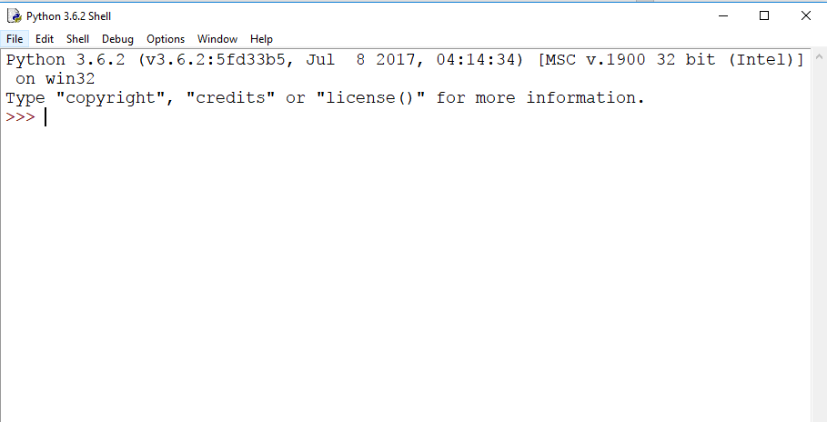 | 1
- a) The editor
- b) The shell
- c) The Python window
- d) The file
8 | Which key is used to run your code? | 1
- a) F4
- b) F1
- c) F5
- d) Enter
9 | When you run your code, what area of Idle does your code run in? | 1
- a) The editor
- b) The shell
- c) The Python window
- d) The file
10 | 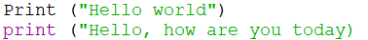  There are 2 syntax errors in the code above. Describe what they are. | 2
Error 1 ………………………………………………………………………………………………….

Error 2 ………………………………………………………………………………………………….
11 | Is the following statement true or false?  Python functions are case-sensitive. | 1
…………………………………………………………………………………………………………….

